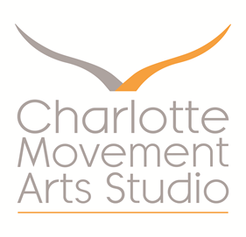
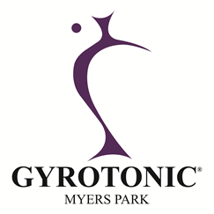

A note on our cancellation policy…

Late cancellations (less than 24 hour notice) can have a significant impact on our business. Cancelled sessions can be difficult for us to refill - particularly when cancelled close to their starting time. Studio time needs to be realized to its fullest potential in order for our business to thrive. In this spirit – we ask our clients to adhere to the following guidelines:
- Please give us 24 hours of advance notice for any cancellations. This advance notice gives us the opportunity to try to refill your slot.
- If the slot can be refilled there is no charge incurred (no matter when you cancel).
- If the slot cannot be refilled, you will be charged the full price of your session (if you did not provide a 24 hour notice).
- Emergency circumstances can happen. Emergencies include severe weather, car trouble, acute illness or an injury that does make it possible for you to give the studio 24 hour notice. In this event, we will evaluate on a case-by-case basis.
- General illness - sick clients are encouraged not to come to the studio so that they do not spread their illness to others. If you are under the weather, please let us know with a 24 hour notice so that we may try to refill your slot. If you end up feeling better closer to your appointment, your appointment may be reinstated or you will be accommodated elsewhere in the studio schedule.
- Standing appointment cancellations – if, over a 3 month period of time, a standing appointment is cancelled 50 - 70% of the time or more, we reserve the right to revert that appointment back into our general schedule so that it can be made available to our clientele.

Please feel free to contact us with any concerns or questions that you have.

Kind regards,

Charlotte Movement Arts Studio

